

Agency Agreement
Date:

This agreement is made between,  Zero Developments Co., Ltd.  Represented by its authorized Director Mr. Robert Hodge  Tax ID: 0835566045831  123/24-25 Moo. 5 Cherngtalay Sub-District, Thalang District, Phuket Province 83110  (Hereinafter referred to as the developer) | And,  (Represented by its authorized Director Agency Name)  Address:  Tax ID:  Phone: -  Email: -  (Hereinafter to as the agency)

1.⁠ ⁠Non Exclusive Representation
The Developer hereby appoints the Agency to act as a non-exclusive marketing and sales agent for the listed project contained in this agreement.

2.⁠ ⁠Conditions
2.1 This agreement shall take effect as of the date of signing the Sales & Purchase Agreement. Either party may terminate the agreement with one month's notice. The agent shall inform The Developer of their client's name via email to reserve that client for the agent. This must be done as soon as the agent decides to show the client the project.
2.2 The conclusion of an agreement with a Client’s affiliate shall be considered as introduction by the Agent and the Agent will be entitled to receive the commission under this Agreement.
2.3 The Developer shall register all the further transactions with the Client (independently how much time has passed from Client introduction) as introduced by the Agent and shall pay the Agent’s Commission specified hereby.
2.4 The Agent shall send the Client's contact details to the Developer by e-mail. The Developer shall confirm to the Agent the fact of receipt of the referral letter within two days after receipt of the referral letter or refuse to register the Client. Client registration confirms the fact of Client's submission by the Agent.
2.5 The Developer shall inform the Agent about each deal with the Client during 3 days after the deal.
2.6 The Developer undertakes not to contact the client on its own initiative during the period from the moment of his registration with the Agency until the general online or offline meeting.
2.6 Registration is valid for 3 months from the moment of registering the client.

3.⁠ ⁠Scope of Agencies/Agents Services and Obligation
Agent services may include, but are not limited to:
A) Introduce the project to the agent's national and international clients.
B) List the project on the agent's website.
C) Advertise the project in the agent's office.
D) Introduce the project to international subagents (if any)-
E) Send email newsletters about the project to potential clients.
F) To offer the project for sale at the price indicated by the developer.

4. Commission and Payment
The sales commission payable to the agent for carrying out the sales activities (hereinafter referred to as the commission) shall be under the following conditions:

- 10% of the unit price for each unit condominium sold

Payment of the commission will be made within 14 working days of the receipt of the first of the installment from the client (25 or 35% of the selling price following the SPA agreement). Commission is included VAT or Withholding tax, the developer entitled to deduct VAT or Withholding tax before the pay the commission as required by Thai Laws.

No agreement between The Developer and any third party or parties shall affect the legal rights of the agent, including but not limited to the right to receive the commission.

All payments from any prospective buyer shall be made directly to the developer's account:

Account Name: The Zero Bangtao Co., Ltd.
Account Number: 475-1-23580-5
Name of the Bank: Bank of Ayudhya Public Company Limited
Bank Branch: Choeng Thale Phuket
Bank Address: 356/3-4, Moo 1, Si Sonthon Rd., Choeng Thale, Thalang, Phuket, 83110 Thailand
SWIFT Code: AYUDTHBK
Payment Details: Purchase/Lease of Condo Unit no. [Unit Number] at The Zero Bangtao for (Buyer's name)

*All other payments from the Buyer should be made to the Developer account listed above.

This Agreement is made in two copies having the exact same message. The Parties having read this Agreement and understood its purpose thoroughly, have hereunto set their hands in the presence of witnesses on the day, month, and year first written above and each holds a copy.


Execution

The Developer Signature: __________________
(Mr. Robert Hodge)
For and on behalf of Zero Developments Co., Ltd.​ Date:

The Agency Signature:
( )
For and on behalf of ( Agency Name)

Date:___________________

Annex 1

A copy of Developer’s company affidavit and the Authorized Director’s Passport

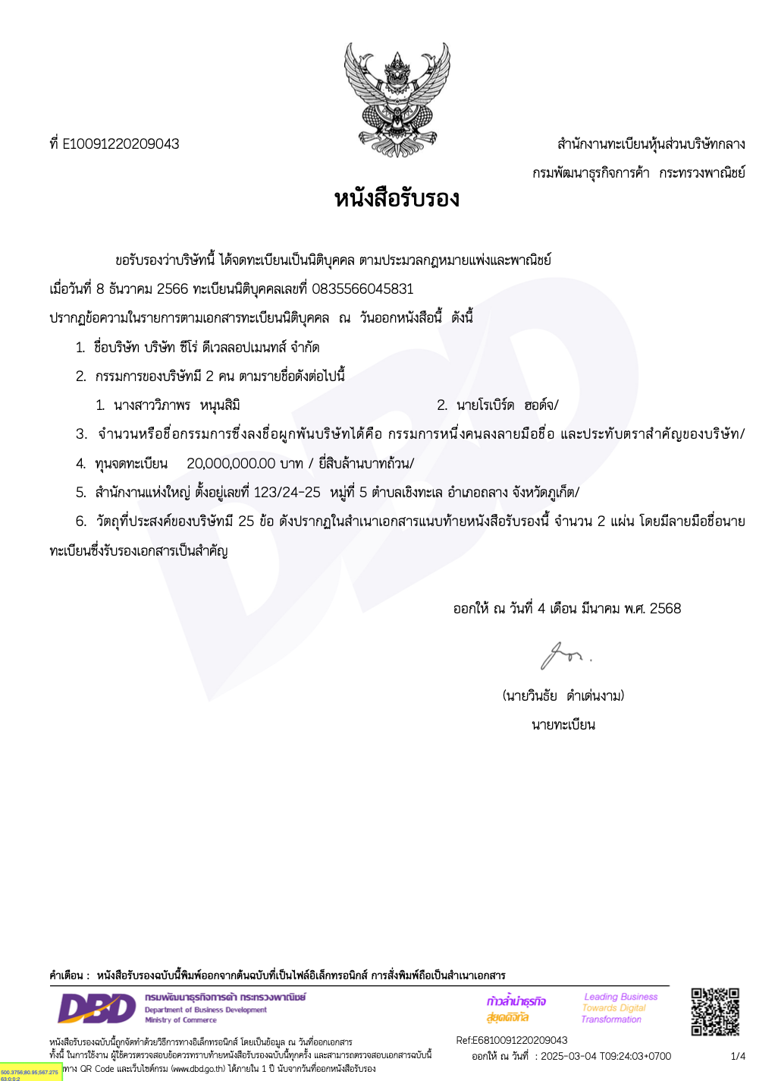

A copy’s of the Authorized Director’s Passport

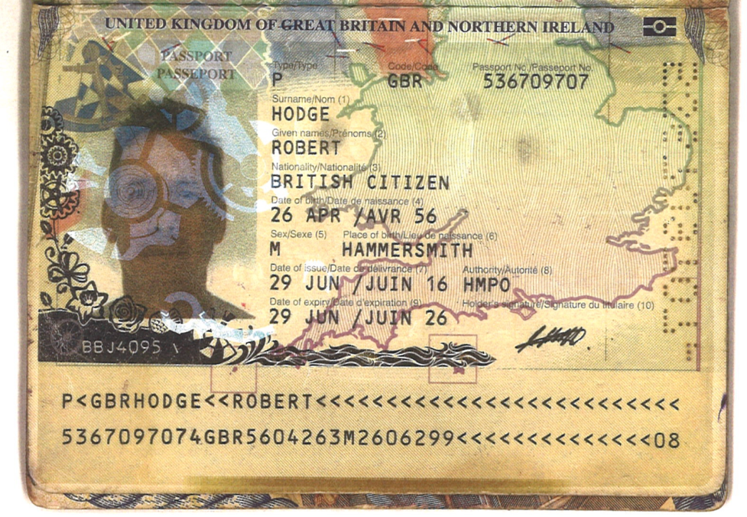

Annex 2

A copy of Agent’s company affidavit and the Authorized Director’s Identification Card

